BCN5722: Advanced Planning and Control

Module 1 Module 2 Module 3 Module 4 Exam 1 Module 5 Module 6 Module 7 Module 8 Exam 2
.
START HERE:
Read and familiarize yourself with all the information in the syllabus below at the start of the semester, then during the semester we will work through the modules in the order presented.
INSTRUCTOR:
Dr. Ian Flood, room RNK 316, Rinker School, College of Design, Construction and Planning, University of Florida, Gainesville, FL 32601, USA. Email: flood@ufl.edu
SCHEDULE AND OFFICE HOURS:
For class times please see my schedule. If you have a question or need an appointment, we can either meet in my office, via a private Zoom meeting, by phone, or by email, whichever you prefer. To arrange a meeting, please either send me an email (flood@ufl.edu) or ask me at the end of class.
PREREQUISITES:
None.
SUBJECT:
The understanding and solution of complex planning, monitoring, and control problems arising in construction, using basic and advanced planning tools.
OBJECTIVES:
To learn the use and application of basic and advanced tools to the planning, monitoring, and control of residential, commercial, industrial, and heavy construction projects.
Students taking this course will first develop a comprehensive understanding of the fundamentals of planning, monitoring and controlling a construction project using CPM (Critical Path Method) and its related techniques. The course then builds upon this basic knowledge, developing expertise in dealing with problems such as uncertainty in the performance of resources, modeling repetitive construction work, simulating construction processes, and optimizing project plans. The course concludes with an introduction to emerging and possible future approaches to project planning.
The course will provide students with a comprehensive understanding of the issues, tools and methods necessary to be able to act at the forefront of project planning well into the 21st century.

COURSE CONTENT:
The course material (including lecture notes, presentations, interactive media and assignments) should be followed in the order presented.
Module 1: Introduction to Project Planning
Module 2: The Critical Path Method
Module 3: Uncertainty and the PERT Method
Module 4: Uncertainty and the Monte Carlo Method
Exam 1: Sample exam questions and model answers for 1st exam
Module 5: Repetitive Construction and Linear Scheduling
Module 6: Construction Simulation
Module 7: Advanced Resource Management and Plan Optimization
Module 8: Emerging and Future Planning Techniques
Exam 2: Sample exam questions and model answers for 2nd exam
REFERENCES:
There is no single text that covers all aspects of this course. Therefore there is no specific text recommended for purchase. Instead, this website provides a comprehensive set of notes, presentations, tutorials, interactive media and assigned readings. The following books are suggested for general reference:
- Construction Planning, Programming and Control, by Cooke and Williams, published by Wiley Blackwell, 3rd edition, 2009.
- Construction Project Management, by Sears, Sears, Clough, Rounds & Segner, published by John Wiley and Sons Inc., 6th edition, 2015.
- Design of Construction and Process Operations, by Halpin and Woodhead, published by John Wiley and Sons Inc., 1976.
- Project Planning and Control Using Primavera P6 Versions 8.1, 8.2 & 8., by Harris, 2013.
- RSMeans Building Construction Cost Data, by Plotner, published by R S Means and Co Inc., 2014.
INSTRUCTIONS ON SUBMITTING ASSIGNMENTS:
Online submission of assignments requires files to be in either MS Word, Excel or PDF format - each assignment identifies the file type(s) that it permits. All answers to an assignment must be put in the correct order with the question clearly identified, and submitted within just one file. Placing all parts of a question in one file can be achieved by several means, for example: (a) in MS Word you can type-in answers, draw pictures, and cut&paste or import images and other objects; (b) Windows provides an easy to use Snipping Tool that allows you to gather images from any part of the screen and then paste them into the file to be submitted; and (c) you can use a scanner to create a single pdf file for submission.

GRADING:
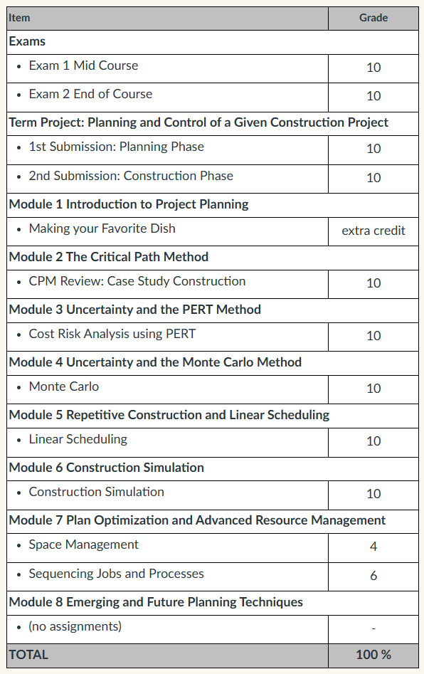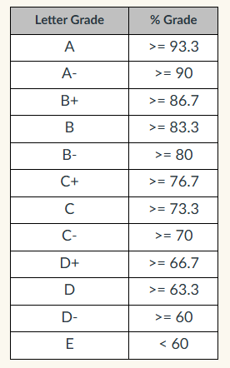
Homework that is submitted late will usually be penalized at a rate of 10% per day.
HARDWARE AND SOFTWARE REQUIREMENTS:
To follow this course you will need:
- Internet access (required throughout the course).
- Microsoft Office including, Word, Excel and PowerPoint (required throughout the course).
- Adobe Acrobat Reader (required throughout the course - click here to download a copy).
- Oracle Primavera P6 (student version, required throughout the course - downloading and installation instructions are provided in Module 2).
- DOS Box for Windows (required in Module 6 - downloading and installation instructions are provided in Module 6).
- CYCLONE Simulation Software (required in Module 6 - downloading and installation instructions are provided in Module 6).
ACCOMMODATIONS:
Students with disabilities requesting accommodations should first register with the Disability Resource Center (352-392-8565, www.dso.ufl.edu/drc/) by providing appropriate documentation. Once registered, students will receive an accommodation letter which must be presented to the instructor when requesting accommodation. Students with disabilities should follow this procedure as early as possible in the semester.

ONLINE COURSE EVALUATIONS:
“Students are expected to provide professional and respectful feedback on the quality of instruction in this course by completing course evaluations online via GatorEvals. Guidance on how to give feedback in a professional and respectful manner is available at https://gatorevals.aa.ufl.edu/students/. Students will be notified when the evaluation period opens, and can complete evaluations through the email they receive from GatorEvals, in their Canvas course menu under GatorEvals, or via https://ufl.bluera.com/ufl/. Summaries of course evaluation results are available to students at https://gatorevals.aa.ufl.edu/public-results/.”Links to an external site.

HONOR CODE:
All students in this course are subject to the requirements of the University of Florida’s Honor Code <https://www.dso.ufl.edu/sccr/process/student-conduct-honor-code/>. Cheating will not be tolerated. Although joint work on assignments may be acceptable in some cases, duplication of an assignment either manually or electronically will be dealt with as an act of academic dishonesty. “We, the members of the University of Florida community, pledge to hold ourselves and our peers to the highest standards of honesty and integrity.”

RESERVATIONS AND REMEDIES:
The instructors reserve the right to modify the course schedule and modules as deemed fit. If any questions, issues, or concerns about the course (assessment, policies, schedule, etc.), please contact the instructor to remedy any issue.

ACCESSING UNIVERSITY ACADEMIC POLICES AND ACADEMIC POLICIES AND CAMPUS RESOURCES:
To support consistent and accessible communication of university-wide student resources, please use this link to academic policies and campus resources: https://go.ufl.edu/syllabuspolicies

Course Summary:
Date | Details | Due
 | Assignment 0 Group Term Project Part 1
 | Assignment 0 Group Term Project Part 2
 | Assignment 1 Making your favorite dish
 | Assignment 2 CPM Review: Case Study
 | Assignment 3 Cost Risk Analysis using PERT
 | Assignment 4 Monte Carlo Based CPM
 | Assignment 5 Linear Scheduling and Learning Effects
 | Assignment 6 Evaluating an Excavator-Truck Earth Moving Operation using CYCLONE
 | Assignment 7.1 Space Management
 | Assignment 7.2 Sequencing Jobs and Processes
 | Assignment Exam 1
 | Assignment Exam 2

