SYLLABUS – Fall 2023

BCN 6580 & ICM 6680 – High-Performance Green Building Delivery Systems
Accessible via e-Learning/ CANVAS

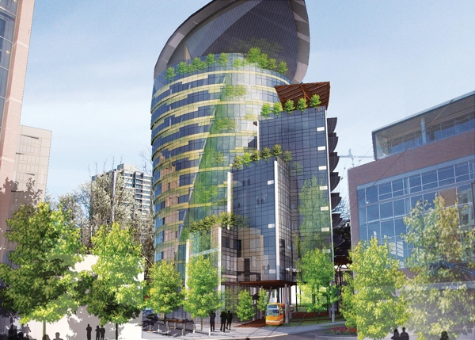

Prerequisites: Graduate standing, BCN 6585, or instructor approval
Description: The purpose of the course is provide an overview of emerging delivery systems for high performance green buildings and the basis on which their sustainability can be evaluated. Green building assessment including US and international systems will be covered.
Key Words: Green Buildings, High-Performance Buildings, building assessment, Sustainable Construction
Method: Lectures; research papers; oral presentations; work on real world LEED, Green Globes, LBC projects; field trips; guest lectures
Objective: Upon completion of this course, the student will be conversant with the subject of high-performance green building design and delivery systems, the USGBC LEED suite of building assessment standards, Green Globes, and the Living Building Challenge.
Course Outline: This course is organized on a weekly schedule with assigned readings and projects. Each module consists of readings, analyses, and exercises.
Instructor: Dr. Ravi Shankar Srinivasan
sravi@ufl.edu
Course Prepared by: Dr. Charles J. Kibert
Required Text: Kibert, C. J. “Sustainable Construction: Green Building Design and Delivery,” Fourth Edition, New York: John Wiley & Sons, Inc., 2016

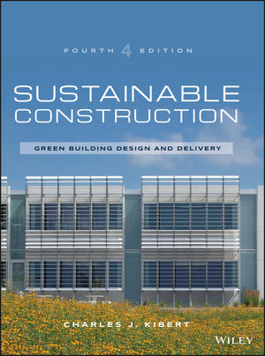
References:
Environmental Building News, monthly green building newsletter http://www.buildinggreen.com
Eco-Structure, AIA, http://www.ecco-structure.com
Green Source, McGraw Hill Construction and BuildingGreen,http://greensource.construction.com
High Performance Buildings, ASHRAE publication, http://www.HPBmagazine.com
Late Assignments. Late assignments will incur an immediate 20% point penalty for the first 24 hours and will receive no credit if received after this time. Assignments are due to the instructor by the start of class on the due date in both hard and e-copies. Honor Policy. It is Rinker School policy that any incidence of cheating, copying, signing rosters for others, or other attempts to deceive will be penalized by course failure.
STUDENT ASSIGNMENTS AND EVALUATION
Grading: The final student grade will be a letter grade based on the percentage of the Total Points Achievable. The grades based on the percentage are as follows: The grades based on the percentage rounded to the nearest whole number are as follows:
A: 95 and up, A-: 92-94.5 B+:88-91, B: 83-87, B-: 80-82, C+: 77-79, C: 73-76, C-: 70-72, D+: 67-69, D: 63-66, D-: 60-62, E: 59 or below.

Course Requirements: The required papers and projects for this course are described below.
A. HPB Project (175 points)
1. Part 1: LEED: 50 points
2. Part 2: Green Globes: 50 points
3. Part 3: LBC : 50 p0ints
4. Project Oral Report: 25 points

B. HPB Papers (two papers, 100 points each)

C. HPB Paper Oral Reports ( 2 oral reports, 25 points each)

D. HPB Technology Reports (25 points)
1. Technical Systems (MEP)
2. Non-Technical Systems (materials/products)
3. Software/Tool

E. Quizzes: 20 points each

Total Points = 500 points + Quizzes

NOTES:
(1) Project is by two person Group, all other assignments are Individual.
HPB Project: LEED/Green Globes/LBC
Students will be divided into teams and each group will be assigned or select a building project for application of high-performance green building approaches. This project has three components: (1) LEED and (2) Green Globes building (3) Living Building Challenges assessment systems. A 15 minute oral report by the team is required.

HPB Papers
Papers should be 1,500 words =/- 10%. Papers will be hard copy and posted to Canvas. Two 10-15 minute (+/- 1 minute) Powerpoint oral report will be given as directed by the Instructor.

HPB Tech Reports
Students will produce three Powerpoint oral reports: (1) Technical Systems, (2) Non-Technical Systems, and (3)( Software/Tools. Oral reports are 10 minutes with Powerpoint. An e-copy of the Powerpoint will be posted to Canvas by the due date.

HPB Paper Format
Format as specified by journal Energy and Buildings. Do not provide a cover page. Provide an abstract, keywords, and references. You must provide at least 10 references from authoritative sources (not the internet, not Wikipedia, not company newsletters). You can use journals, EBN, books, and other well-respected publications such as Scientific American, the New York Times, and the Economist.

DUE DATES
See Due Dates Handout on Canvas

Quizzes: A quiz may be given at the start of each class on the assigned tasks for that class. Students are required to complete all assignments prior to class and be prepared for in-depth discussion in class. Each quiz has a value of 20 points.

Modules
1. Introduction to high-performance green buildings
2 Methods and tools for building assessment and LEED
3 The green building process and Green Globes
4 Ecological Design and the Living Building Challenge (LBC)
5 Location, site, landscape strategies
6 Building energy system analysis and strategies
7 Building hydrologic cycle analysis and strategies
8 Materials selection analysis and strategies
9 Indoor Environmental Quality (IEQ) analysis and strategies
11 Commissioning/Construction team roles
12 Green building codes, standards, and economics

