Syllabus
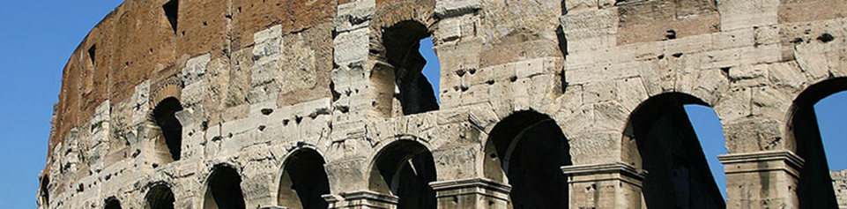UNIVERSITY OF FLORIDA
M.E. RINKER SCHOOL OF CONSTRUCTION MANAGEMENT

BCN 4956: History of sustainable construction in Italy

Instructors Mark Russell, PhD, PE, Maria Watson, PhD
Office Hour: Most days 14:00 -16:00 M- F 12:00 – 16:00
Office Location: RNK 331 RNK 203
Email: russ1307@ufl.edu, maria.watson@ufl.edu

Course Description
This course provides an overview of the history of sustainable construction techniques in Europe with an emphasis on Italian techniques. The integration of international sustainable practices will be evaluated and demonstrated through literature review, lectures, and site tours. The methods for practical application of the European techniques on US construction sites, will be incorporated into all presentations.

Course Learning Objectives:
- The student will be able to explain the differences in construction philosophy between US, Europe, and Italy. Particular attention is dedicated to understanding the variations in job site safety techniques and sustainable principles.

- The student will be able to explain the evolution of the construction techniques and their impact on project efficiency.

- The student will be able to comprehend the significance of construction material selection relative to design and the impact on project management. The selection of equipment and prediction of results will be a significant portion of the evaluation.

ACCE Student Performance Criteria this course could meet:

1. Speaking and Writing Skills
Ability to read, write, listen, and speak effectively

2. Critical Thinking Skills
Ability to raise clear and precise questions, use abstract ideas to interpret information, consider diverse points of view, reach well-reasoned conclusions, and test them against relevant criteria and standards.

Required Readings
There will be a set of readings made available prior to the trip and these will be discussed in
Class. Students will be expected to be prepared and come to class ready to discuss. However, there are no requirements to purchase books for this course as the papers will be available for download prior to departure. Additional readings will be assigned during the course of the trip. The following is a list of books that will serve as a starting point:

Title | Author
The Colosseum (Wonders of the World) | Hopkins, Keith
Basilica: The Splendor and the Scandal: Building St. Peter’s | Scott, R.A.
Roman Building Techniques | Rook, T.
Mussolini’s Rome | Pugliese, S.
Constructing the Ancient World: Architectural Techniques of the Greeks and Romans | Malacrino, C.
Sustainable Development in Europe: A Comparative Discourse Analysis. | Marhold, H. and Meimeth, M.
Sustainable Construction: Green Building Design and Delivery | Kibert, C.

Class Structure
Each day will represent a separate module. The day will be filled with multiple active learning segments as well as presentations/ lectures/ site visits. Each module will consist of active participation through reading of course materials and required text, lectures, presentations, multiple responses to readings via questions and discussion points in webct and or face to face (these responses are graded and weighted), writing projects and small projects.

Week 01
Module 1 - Historic perspective of European Construction techniques relative to US
Module 2 – Ancient building techniques and their impact on the development of Rome
Module 3 – Residential construction techniques of the Imperial Era.
Module 4 – Advancements in engineering applied to the Public facilities of the Imperial Era.
Module 5 – Religious antiquity and an analysis of the construction techniques

Week 02
Module 6 – Renaissance construction techniques as applied to residential facilities.
Module 7 – Fascist construction methodologies and philosophy
Module 8 – Renaissance construction techniques of religious facilities.
Module 9 - Modern Construction techniques as applied to Italian job sites.
Module 10 - Sustainable techniques, Graduate student presentations, and lessons learned

Grading Summary
Class Participation 20%
Daily Homework Assignments 40%
Individual Presentation 40%
100%
Individual Presentation:
Each student will be expected to select one of the homes from Pompeii and present a tour to the class on the significant features of the home. The emphasis should be focused on how the building is sustainable and the differences in construction materials/ techniques. A short description of Pompeii buildings can be found at: http://www.pompeiisites.org

Homework Assignments:
Day 1: Photos of 3 things that are different in your apartment than in the US
Day 2: Photos of 3 things in town that are different from US
Day 3: Complete LEED scorecard relative to Trajan’s Market. Compare to Zara
Day 4: Visit at least one other Pilgrim site. Provide photo of at least 3 differences to St. Peter’s
Day 5: Photo of at least 3 sustainable products in Pompeii
Day 6: Photo of 3 things Mussolini did that could be considered sustainable.
Day 7: Photo of 3 modern sustainable buildings
Day 8: LEED historic buildings scorecard
Day 9: Photo of 3 sustainable actions in Venice different from rest of Italy.
Day 10: Complete 3 course surveys (for AIFS, UF, and course overview)

University of Florida Policies
To support consistent and accessible communication of university-wide student resources, please use this link to academic policies and campus resources: https://go.ufl.edu/syllabuspolicies.

Itinerary:
May 5 Meet students at Rome Termini Train Station
May 5 - 15 Rome
May 10 Day trip to Pompeii
May 11-12 Free weekend
May 15 - 18 Vicenza
May 16 Meet students at VIA
May 17 Day trip to Venice
May 18 Students depart

