UNIVERSITY OF FLORIDA

M.E. RINKER, SR. SCHOOL OF CONSTRUCTION MANAGEMENT

# BCN 3255 – GRAPHIC COMMUNICATION IN CONSTRUCTION (3 credits)

**INSTRUCTOR:** Dr. Masoud Gheisari

Room 322 Rinker Hall, Phone: 352-273-1166

**OFFICE HOURS:** TAs will be available during office hours

And any other time by appointment

**COURSE WEBSITE:** Canvas <https://lss.at.ufl.edu/>

**EMAIL:** Mail tool in Canvas

**PREREQUISITES:** BCN 1251 - Construction Drawing (Successful completion of Construction Drawing automatically ensures that the student has the prerequisite for this course as it is now designed.)

## COURSE DESCRIPTION

This course introduces students to various construction communication tools including building information modeling (BIM), the use of computer-aided drafting (applications of 4-D modeling in construction), piece-based simulations, and blueprint reading. The goal of the course is to help students understand how to apply these communication tools to successfully manage construction process.

### COURSE METHOD

* The class meets twice weekly for two hours.
* Class will have integrated lecture-lab format.
* Students are expected to **stay in the class** until they satisfactorily complete and turn-in their assignments.

### COURSE OBJECTIVES

To teach the student to read, understand and use construction documents, and use building information modeling (BIM) technology. The goal of the course is to help students understand how to apply these communication tools to successfully manage construction process.

### COURSE LEARNING OUTCOMES

Upon completion of the course students will demonstrate their ability to:

➊ Read, understand and use construction documents (construction drawings and project specifications) (SACS 5, ACCE SLO 7)

➋ Use building information modeling (BIM) technology for preconstruction modeling (SACS 5, ACCE SLO 10)

➌ Visualize a building and construction process by creating a building information model of a selected building (SACS 5, ACCE SLO 7, 10)

➍ Recognize the possibility for using BIM for estimating, scheduling, facility management, and energy analysis (SACS 5, ACCE SLO 10)

*SACS = Southern Association of Colleges and Schools*

*ACCE = American Council for Construction Education*

*SLO = Student Learning Outcome*

*SACS 5: Communicate technical and financial data effectively in speech and in writing to all stakeholders in the construction process.*

*ACCE SLO 7: Analyze construction documents for planning and management of construction processes.*

*ACCE SLO 10: Apply electronic-based technology to manage the construction process*

**TEXTBOOK**

*Commercial Design Using Autodesk Revit (Latest Version),* Daniel John Stine, SDC Publications,

**REQUIRED EQUIPMENT, MATERIAL, AND SOFTWARE**

**Hardware Requirements:**

* **Mouse**
  + The **mouse** with a **scroll wheel** is **required** for this class.
* **Laptop**
  + The **laptop** computer is **required** for all the students in the Rinker School. Therefore, in this class you will be allowed to work only on your own laptop. If anything goes wrong with your laptop, notify the instructor as soon as the problem occurs. In that case, you will be allowed to use only the computers in the Rinker School computer lab. If you use anyone else’s computer (besides your own or a computer in the Rinker School computer lab), it will be considered violation of the Rinker School policy and, thus, will be dealt with accordingly.
  + For more information about **BCN’s computer requirements** visit the website: <https://dcp.ufl.edu/rinker/academics/computer-requirements/>

**Software Requirements:**

Autodesk Revit, Navisworks Manage, Microsoft Project, and etc.

**It is your responsibility to make sure you have all the hardware and software requirements on your computer for this class.**

**GRADING CRITERIA**

Grades are viewed as a means to communicate evaluation of your work and progress. Specific evaluation criteria will be provided with each exam/project/class activity. Work will be evaluated through in-class feedback and/or written commentary. Projects, exams, and individual assignments during the semester will be numerical grades. Each of them will be evaluated and those evaluations will be provided to students based on their request. The breakdown of grades will depend on:

|  |  |  |
| --- | --- | --- |
| **#** | **Item\*** | **Points\*** |
| **1** | Quizzes | 200.00 |
| **2** | Midterm Exam Project | 200.00 |
| **3** | Semester-long Commercial Building Project | 200.00 |
| **4** | BIM-based Technology Reflections/Reports | 100.00 |
| **5** | Assignments | 100.00 |
| **6** | Final Project | 200.00 |
|  |  |  |
|  | Total: | 1000.00 |

*\*Activities and assessments may be modified where necessary as determined by the instructor; proper notification will be given*

Grades will not be curved but you will have various opportunities throughout the semester to achieve extra points for exhibiting more engagement and learning. Your “Total Points” will be divided by 10 and then your grades will be computed according to the following scale:

|  |  |  |  |  |
| --- | --- | --- | --- | --- |
| **A** 93.00-100 | **B+** 87.00-89.99 | **C+** 77.00-79.99 | **D+** 67.00-69.99 | **E** less than 60.00 |
| **A-** 90.00-92.99 | **B** 83.00-86.99 | **C** 73.00-76.99 | **D** 63.00-66.99 |  |
|  | **B-** 80.00-82.99 | **C-** 70.00-72.99 | **D-** 60.00-62.99 |  |

**ASSESSMENT METHODS AND TARGETS**

|  |  |  |  |  |  |
| --- | --- | --- | --- | --- | --- |
| **Assessment** | **CLO 1** | **CLO 2** | **CLO 3** | **CLO 4** | **Target** |
| Quizzes | **X** | **X** |  | **X** | At least 80% receive a C- or better |
| Midterm Exam | **X** | **X** |  |  | At least 80% receive a C- or better |
| Semester-long Commercial Building Project |  |  | **X** |  | At least 80% receive a B- or better |
| BIM-based Technology Reflections/Reports |  |  |  | **X** | At least 80% receive a B- or better |
| Navisworks Assignments |  |  |  | **X** | At least 80% receive a B- or better |
| Final Project |  | **X** | **X** | **X** | At least 80% receive a C- or better |

**CLASS ATENDANCE**

* **Attendance is strongly encouraged.** In-class assignments/activities/quizzes might be given each lab-lecture periods. You need to work on the assigned lecture exercises/lab assignments/quiz during the class. However, if you are not there or you do not work on the assigned exercise/quiz during the class you cannot get credit for participation and assignments. Additionally, extra credit points are occasionally awarded for attendance and participation in the lecture.
* There are **no make-ups** for missed classes unless you discuss your absence with the instructor **before** the classes you miss and provide appropriate **documentation within 1 week** to support your absences.
* In the case of an excused absence, you need to do the make up quiz NOT LATER THAN A WEEK AFTER THE ABSENCE DAY; otherwise you will receive a zero for that quiz.
* If you miss a class, please make arrangement to discuss the missed session with a classmate. You should also get notes from other students.
* If you will miss a class, you must complete and **submit your assignment in advance**, i.e. **before** the class you will miss.

**ASSIGNMENTS/FINAL PROJECT**

* **Late assignments and late final project will not be accepted, regardless of circumstances.** For late assignments and late final project, student will receive a zero on the assignment/final project.
* All work turned in for this course should have professional quality in content and presentation.
* Assignments may be graded by detailed checking or based on overall attempt. Instructor may choose not to grade some homework.
* All the assignments and final project have to be **submitted exclusively in Canvas.**
* It is **your responsibility** to verify the successful submission of the assignments/final project in Canvas. Submission by **email** or the **digital media** (such as USB drive) **will not be accepted**.
* In the case you have technical difficulties with Canvas, please contact the UF Help Desk at learning-support@ufl.edu, or (352) 392-4357 - select option 2, or go to Ground floor of the Hub. If your technical difficulties will cause you to miss a due date, you MUST report the problem to UF Help Desk **before the due date/time**. Include the ticket number that you are given in an e-mail to the instructor to explain the late assignment due to problem with Canvas.
  + Types of questions that should be directed to the Help Desk:
    - I cannot log into Canvas
    - I have clicked on the "submit" button for my assignment and nothing is happening
    - I cannot upload an assignment
    - Canvas has given me an error message and I cannot submit my assignment.
  + Poor internet connections cannot be accommodated with a ticket from the UF Helpdesk.
  + The instructor reserves the right to accept or decline tickets from the UF Helpdesk based on individual circumstances.
* An introduction and support for the E-Learning in Canvas system can be found at:  
  <https://lss.at.ufl.edu/help/Student_Faq>
* Due to the nature of the class and the Revit/Navisworks software, any consultation regarding assignments/final project and the use of the software will be conducted exclusively **in person**, that is, consultations **via email** **will not be conducted**.

## QUIZZES AND MIDTERM EXAM

* **Quiz/Exam(s) are mandatory** and scheduled in advance so plan to attend them at scheduled time.
* There are no make-ups for the missed quizzes and midterm exam.
* In the case of an excused absence, you need to do the make up quiz NOT LATER THAN A WEEK AFTER THE ABSENCE DAY; otherwise you will receive a zero for that quiz.

### STUDENT EVALUATIONS

Students are expected to provide professional and respectful feedback on the quality of instruction in this course by completing course evaluations online via GatorEvals. Guidance on how to give feedback in a professional and respectful manner is available at <https://gatorevals.aa.ufl.edu/students/>. Students will be notified when the evaluation period opens, and can complete evaluations through the email they receive from GatorEvals, in their Canvas course menu under GatorEvals, or via <https://ufl.bluera.com/ufl/>. Summaries of course evaluation results are available to students at <https://gatorevals.aa.ufl.edu/public-results/>.

### COMMUNICATION WITH THE INSTRUCTOR AND TEACHING ASSISTANT

* Use the **Canvas** environment to send **emails** to me and teaching assistant(s). **Do not email me and teaching assistant outside of the Canvas system because emails received outside of Canvas will not receive a response.**
* Please try to communicate with me and teaching assistant(s) **during office hours**.
* Please allow 24 hours for a response to your email through Canvas. Teaching assistant and I reserve the right not to respond to course inquiries on the weekend as well as on the weekdays after 5 p.m.
* When emailing us through CANAVS please CC me and all TAs to make sure one of us would get back to you ASAP.
* Any communication regarding **grades** will be conducted only **in person,** as communication about grades via email or phone is not considered a safe practice. **Any inquiry about the grades must be made within one week after the grade release date.**

## HONOR CODE

* **The Honor Code will be applied in the class.** We, the members of the University of Florida community, pledge to hold ourselves and our peers to the highest standards of honesty and integrity. On all work submitted for credit by students at the university, the following pledge is either required or implied: **"On my honor, I have neither given nor received unauthorized aid in doing this assignment."**
* **Duplication of an assignment** **and quiz/exam/project/activity** both manually or by computer will be considered an act of academic dishonesty and dealt with accordingly. Any violation of the Honor code will not be tolerated. A student that is found guilty of Academic Dishonesty will be given a **failing grade** for the course.
* Do not allow others to access or work on your files as that will also be considered violation of the Honor Code.
* Visit the website <http://www.dso.ufl.edu/sccr/honorcodes/honorcode.php> for more information about the University of Florida Student Honor Code.

**DISABLED STUDENTS**

* Any student that needs accommodation regarding physical access, class attendance, notes, or lectures please contact me.
* Students requesting classroom accommodation must first register with the Dean of Students Office. The Dean of Students Office will provide documentation to the student who must then provide this documentation to me when requesting accommodation.

**CLASS DEMEANOR**

* All **cell phones** should be **turned off**.
* **No text messaging** during class.
* **Arriving late** to the class or **leaving before** the end of the class will **not be accepted**. If you are attending the class, you need to be there from the beginning until the end of the class.
* **Exam(s):** You may leave the exam at any time for any reason, but there will be no re-entry into the exam room. You need to submit your exam before you leave the room. If you will need to leave the room for medical or psychological reasons, be sure to provide me with documentation from the Office for Students with Disabilities.

**CLASS SCHEDULE\***

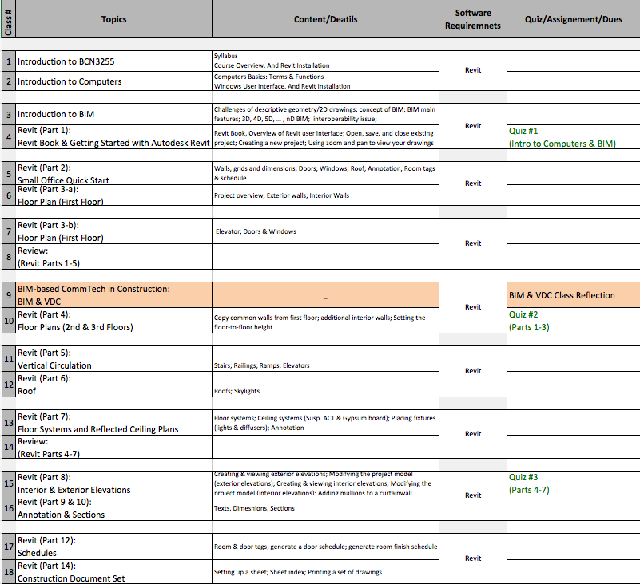

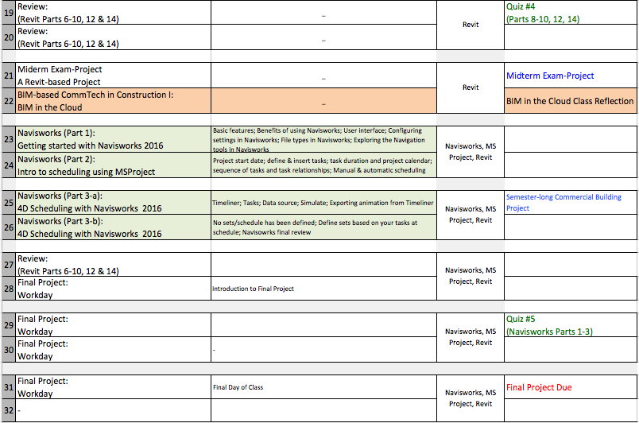

*\* The syllabus represents my current plans and objectives. As we go through the semester, those plans might need to be changed to enhance the class learning opportunity. Such changes, communicate clearly, are not unusual and should be expected.*

**COURSE ROADMAP**

