The Gulf Coast: Resilient Urbanism in a Time of Change
Credit Hours: 3
Meeting Time: Thursdays | Periods 10-12 (4:10-7:10pm)
Location: TBD

INSTRUCTORS
Jeff Carney – Director, Florida Institute for Built Environment Resilience (FIBER)
Carla Brisotto, Ph. D. – Asst. Director, Florida Institute for Built Environment Resilience (FIBER)
Christian Calle Figueroa – Asst. Scholar Florida Institute for Built Environment Resilience (FIBER)

COURSE DELIVERY:
- In person for main campus students
- Online is available to students from CityLabs

PURPOSE OF COURSE
The course introduces students to the theoretical and methodological principles behind the design of resilient cities in a time of enormous change. The focus will be on the U.S. Gulf Coast. Students in this course will investigate and discuss the complex challenges facing the fragile environment and region from the Everglades to coastal of Texas. We will look at the delicate balance between people inhabiting these places and the ecosystem that surrounds them. We will delve into novel design practices emerging from these places. Lastly, we will explore methods for analyzing, viewing, and designing in this natural, urban, and social environment using computational modeling, gaming methods, and AI.

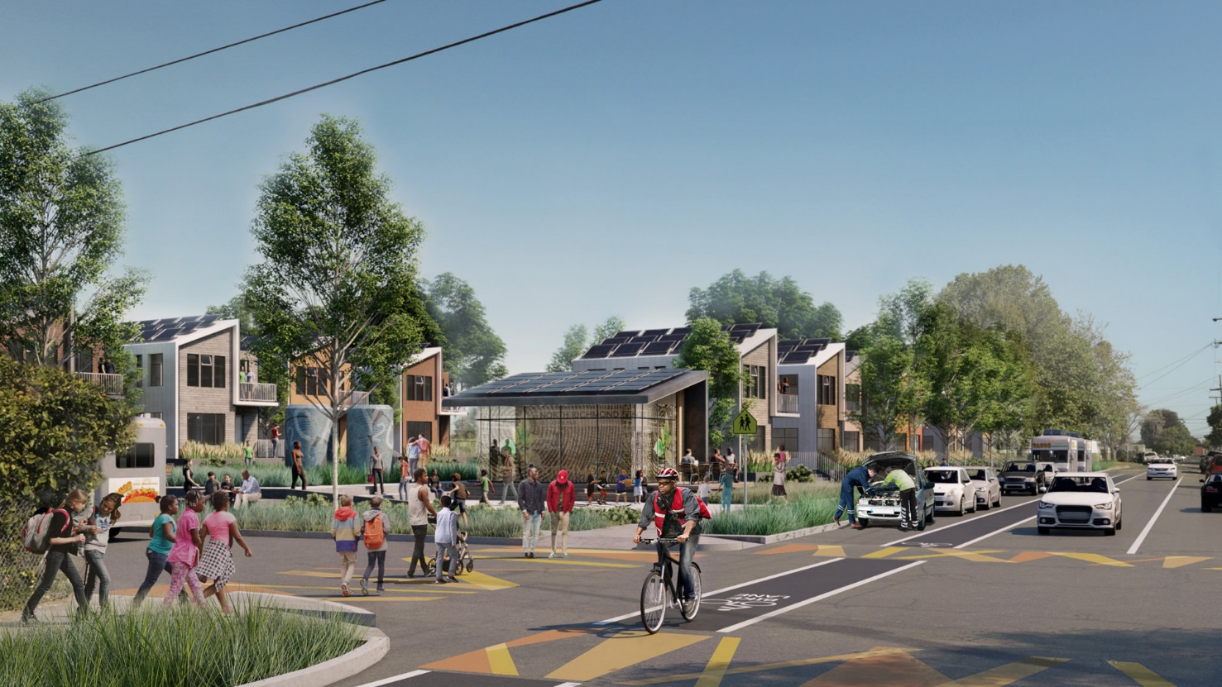
Mithun, Resilient by Design Bay Area Challenge

COURSE DESCRIPTION:
The course will have (3) three-week modules each led by a different instructor on the following topics:
- People and Places of the gulf Coast
- Design practice for a changing environment
- Advanced computational methods and visualization

ASSIGNMENTS:
- Case study review (500 words) based on Module 1
- Case study review (500 words) based on Module 2
- Case study review (500 words) based on Module 3
- Final Project – “DeZine for a change!” Instructors will provide a list of sites along the Gulf Coast and a future scenario prompt. The assignment is to create a Zine to imagine and illustrate what design processes you as an architect can do now to solve future problems as defined by your prompt: DeZine for a change!

