UNIVERSITY OF FLORIDA
M.E. RINKER, SR. SCHOOL OF CONSTRUCTION MANAGEMENT

BCN 3255 – GRAPHIC COMMUNICATION IN CONSTRUCTION (3 credits)

Fall 2023

INSTRUCTOR: Dr. Masoud Gheisari
Room 322 Rinker Hall, Phone: 352-273-1166

TEACHING ASSISTANTS: Jiun-Yao Cheng
Yuan Sun
Ajit Devkota
TAs’ Room: RNK 340 & Virtual Zoom Office

CLASS TIME/ROOM: Section 8936: Tue & Thu 08:30am-10:25am @ RNK 240
Section 0632: Tue & Thu 11:45am-13:40pm @ RNK 240

OFFICE HOURS: TAs will be available during office hours at their
Virtual Zoom Offices are accessible through the following links

Tue. 10:40–11:30am Zoom: https://ufl.zoom.us/my/yuansun
Wed. 01:55–2:45pm Zoom: https://ufl.zoom.us/my/ajitdevkota
Thu. 04:05–04:55pm Zoom: https://ufl.zoom.us/my/ajitdevkota
And any other time by appointment

COURSE WEBSITE: CANVAS https://lss.at.ufl.edu/

EMAIL: Mail tool in CANVAS

PREREQUISITES: BCN 1251 - Construction Drawing (Successful completion of Construction Drawing automatically ensures that the student has the prerequisite for this course as it is now designed.)

COURSE DESCRIPTION
This course introduces students to various construction communication tools, including building information modeling (BIM), the use of computer-aided drafting (applications of 4-D modeling in construction), piece-based simulations, and blueprint reading. The goal of the course is to help students understand how to apply these communication tools to successfully manage construction process.

COURSE METHOD
- The class meets twice weekly for two hours. The class will have an integrated lecture-lab format where lectures and labs happen back-to-back throughout class time.
- Students are expected to stay in the class until they satisfactorily complete and turn in their assignments. A student is allowed to complete an assignment at home only if the student has remained for the full class period and needs additional time to complete the assignment.

COURSE OBJECTIVES
To teach the student to read, understand and use construction documents and use building information modeling (BIM) technology. The goal of the course is to help students understand how to apply these communication tools to successfully manage construction process.

COURSE LEARNING OUTCOMES
Upon completion of the course, students will demonstrate their ability to:
Read, understand and use construction documents (construction drawings and project specifications) (SACS 5, ACCE SLO 7)
Use building information modeling (BIM) technology for preconstruction modeling (SACS 5, ACCE SLO 10)
Visualize a building and construction process by creating a building information model of a selected building (SACS 5, ACCE SLO 7, 10)
Recognize the possibility for using BIM for estimating, scheduling, facility management, and energy analysis (SACS 5, ACCE SLO 5, ACCE SLO 10)

SACS = Southern Association of Colleges and Schools
ACCE = American Council for Construction Education
SLO = Student Learning Outcome

SACS 5: Communicate technical and financial data effectively in speech and in writing to all stakeholders in the construction process.
ACCE SLO 5: Create construction project schedules
ACCE SLO 7: Analyze construction documents for planning and management of construction processes.
ACCE SLO 10: Apply electronic-based technology to manage the construction process

TEXTBOOK
Commercial Design Using Autodesk Revit 2024, Daniel John Stine, SDC Publications, ISBN: 978-1-63057-581-6

HARDWARE AND SOFTWARE REQUIREMENTS
Hardware Requirements:
- Mouse
  - A mouse with a scroll wheel is required for this class.
- Webcam and Microphone
  - A webcam and microphone are required to attend some of the sessions, office hours, and also to take some of the quizzes and tests online. Many laptops come with built-in cameras and microphones; if not, you will be required to have them separately.
- Laptop
  - A laptop computer is required for all the students in the Rinker School. Therefore, in this class, you will be allowed to work only on your own laptop. If anything goes wrong with your laptop, notify the instructor as soon as the problem occurs. In that case, you will be allowed to use only the computers in the Rinker School computer lab. If you use anyone else’s computer (besides your own or a computer in the Rinker School computer lab), it will be considered a violation of the Rinker School policy and, thus, will be dealt with accordingly.
  - For more information about BCN’s computer requirements, visit the website: https://dcp.ufl.edu/rinker/academics/computer-requirements/

Software Requirements:
- Course-related Software:
  - Autodesk Revit 2024
    - Download Link: https://www.autodesk.com/education/free-software/revit
    - You need to create an Autodesk account using your UFL email address
    - The student version is available for free through your Autodesk account
  - Autodesk Navisworks Manage
    - Access through UFApps
  - Microsoft Project Pro
    - Access through UFApps
- UFApps:
  - We will use UFApps to access these software packages.
  - How to Access UFApps
- Go to https://login.apps.ufl.edu/ OR click on the UFApps direct link we provided on the BCN3255 CANVAS page (left bar)
- Login using your GatorLink credentials
- Install the Citrix Receiver or opt to use the Light Version
- Launch your desired application by clicking on the icon/name
- Best Practice: Using UFApps with CANVAS
  - Accessing CANVAS files within UFApps will greatly reduce the steps necessary to get the files you need, complete your work, and then upload them back to CANVAS.
- Once you’re logged into UFApps, launch the E-Learning application
- Login to E-Learning using your GatorLink credentials
      - Now any files you need will be downloaded to your workspace in UFApps

Exam/Quiz/…-related Software:
- Honorlock
  - Some of the exams, quizzes, and in-class projects might be proctored online using Honorlock
  - How to use Honorlock (CANVAS Student Guide): https://www.youtube.com/watch?v=xLSRgrBMz6c&feature=youtu.be
  - Honorlock Student Guide: https://drive.google.com/file/d/1kzVSvd_wlGm0Edaw38PE6KjKhobCQxVt/view

GRADING CRITERIA
Grades are viewed as a means to communicate evaluation of your work and progress. Specific evaluation criteria will be provided with each exam/project/class activity. Work will be evaluated through in-class feedback and/or written commentary. Projects, exams, and individual assignments during the semester will be numerical grades. Each of them will be evaluated and those evaluations will be provided to students based on their request. The breakdown of grades will depend on the following items:

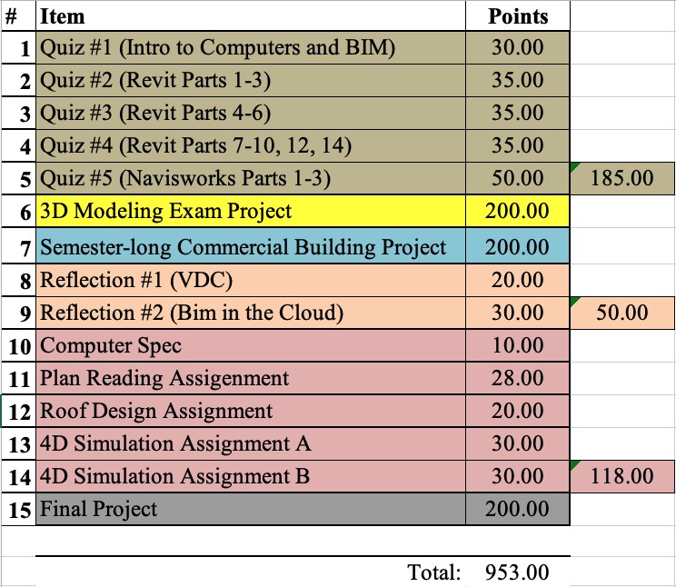
*Activities and assessments may be modified where necessary as determined by the instructor; proper notification will be given
** Undergraduate and graduate section requirements would be different for this item.

Grades will not be curved, but you will have various opportunities throughout the semester to achieve extra points for exhibiting more engagement and learning. Your “Total Points” will be divided by 915 and then your grades will be computed according to the following scale:
Link to the university grades and grading policies.

A 93.00-100 | B+ 87.00-89.99 | C+ 77.00-79.99 | D+ 67.00-69.99 | E less than 60.00
A- 90.00-92.99 | B 83.00-86.99 | C 73.00-76.99 | D 63.00-66.99
 | B- 80.00-82.99 | C- 70.00-72.99 | D- 60.00-62.99

ASSESSMENT METHODS AND TARGETS
Assessment | CLO 1 | CLO 2 | CLO 3 | CLO 4 | Target
Quizzes | X | X |  | X | At least 80% receive a C- or better
Midterm Exam | X | X |  |  | At least 80% receive a C- or better
Semester-long Commercial Building Project |  |  | X |  | At least 80% receive a B- or better
BIM-based Technology Reflections/Reports |  |  |  | X | At least 80% receive a B- or better
Navisworks Assignments |  |  |  | X | At least 80% receive a B- or better
Final Project |  | X | X | X | At least 80% receive a C- or better

CLASS ATTENDANCE
- Attendance is strongly encouraged. In-class assignments/activities/quizzes might be given each lab-lecture period. You need to work on the assigned lecture exercises/lab assignments/quiz during the class. However, if you are not there or you do not work on the assigned exercise/quiz during the class, you cannot get credit for participation and assignments. Additionally, extra credit points are occasionally awarded for attendance and participation in the lecture.
- There are no make-ups for missed classes unless you discuss your absence with the instructor before the classes you miss and provide appropriate documentation within one week to support your absences. The make-up for excused absences could be done only for one week after the absence date.
- If you miss a class, please make arrangements to discuss the missed session with a classmate. You should also get notes from other students.
- If you miss a class, you must complete and submit your assignment in advance, i.e., before the class you miss.

ASSIGNMENTS/FINAL PROJECT
- Late assignments and a late final project will not be accepted, regardless of the circumstances. For late assignments and late final project, the student will receive a zero on the assignment/final project.
- All work turned in for this course should have professional quality in content and presentation.
- Assignments may be graded by detailed checking or based on the overall attempt. The instructor may choose not to grade some homework.
- All the assignments and final project have to be submitted exclusively in CANVAS.
- It is your responsibility to verify the successful submission of the assignments/final project in CANVAS. Submission by email or digital media (such as a USB drive) will not be accepted.
- If you have technical difficulties with CANVAS, please contact the UF Help Desk at learning-support@ufl.edu, or (352) 392-4357 - select option 2, or go to the Ground floor of the Hub. If your technical difficulties cause you to miss a due date, you MUST report the problem to UF Help Desk before the due date/time. Include the ticket number that you are given in an email to the instructor to explain the late assignment due to a problem with CANVAS.
  - Types of questions that should be directed to the Help Desk:
    - I cannot log into CANVAS
    - I have clicked on the "submit" button for my assignment and nothing is happening
    - I cannot upload an assignment
    - CANVAS has given me an error message and I cannot submit my assignment.
  - Poor internet connections cannot be accommodated with a ticket from the UF Helpdesk.
  - The instructor reserves the right to accept or decline tickets from the UF Helpdesk based on individual circumstances.
- An introduction and support for the E-Learning in CANVAS system can be found at: https://lss.at.ufl.edu/help/Student_Faq
- Due to the nature of the class and the Revit/Navisworks software, any consultation regarding assignments/final project and the use of the software will be conducted exclusively in person and consultations via email will not be conducted.

EXAMS AND PROJECTS
- Exam(s) are mandatory and scheduled in advance, so plan to attend them at the scheduled time.
- There is no make-up for the missed quizzes and the midterm exam.
- The progress you make on the “Semester-long commercial building project” as well as the “final project” will be reviewed frequently during the progress check sessions. If you do not show proper progress or miss more than one progress check session, your project grade will automatically be zero!
- All the exams, quizzes, and in-class projects will be proctored online using Honorlock. It would be the students’ responsibility to make sure that they have the required hardware and software to properly run Honorlock during their in-session exams/quizzes/projects/…
  - See the Hardware and Software Requirements section of the syllabus

STUDENT EVALUATIONS
- Students are expected to provide professional and respectful feedback on the quality of instruction in this course by completing course evaluations online via GatorEvals. Guidance on how to give feedback in a professional and respectful manner is available at https://gatorevals.aa.ufl.edu/students/. Students will be notified when the evaluation period opens, and can complete evaluations through the email they receive from GatorEvals, in their CANVAS course menu under GatorEvals, or via https://ufl.bluera.com/ufl/. Summaries of course evaluation results are available to students at https://gatorevals.aa.ufl.edu/public-results/.

COMMUNICATION WITH THE INSTRUCTOR AND TEACHING ASSISTANTS
- Use the CANVAS environment to send an email to me and the teaching assistant(s). Do not email me and the teaching assistant outside of the CANVAS system because emails received outside of CANVAS will not receive a response.
- Please try to communicate with me and the teaching assistant(s) during office hours.
- Please CC me and all TAs within all the communications that you have with us.
- Please allow 24 hours for a response to your email through CANVAS. The teaching assistant(s) and I reserve the right not to respond to course inquiries on the weekend as well as on the weekdays after 5 p.m.
- Any communication regarding grades will be conducted only in person, as communication about grades via email or phone is not considered a safe practice. Any inquiry about the grades must be made within one week after the grade release date.

HONOR CODE
- UF students are bound by The Honor Pledge, which states, “We, the members of the University of Florida community, pledge to hold ourselves and our peers to the highest standards of honor and integrity by abiding by the Honor Code. On all work submitted for credit by students at the University of Florida, the following pledge is either required or implied: “On my honor, I have neither given nor received unauthorized aid in doing this assignment.” The Honor Code specifies a number of behaviors that are in violation of this code and the possible sanctions. Click here to read the Honor Code. Furthermore, you are obligated to report any condition that facilitates academic misconduct to appropriate personnel. If you have any questions or concerns, please consult with the instructor or TAs in this class.
- Duplication of an assignment and quiz/exam/project/activity both manually or by computer will be considered an act of academic dishonesty and dealt with accordingly. Any violation of the Honor code will not be tolerated. A student that is found guilty of Academic Dishonesty will be given a failing grade for the course.
- Do not allow others to access your files, as that will also be considered a violation of the Honor Code.

DISABLED STUDENTS
- Students with disabilities who experience learning barriers and would like to request academic accommodations should connect with the Disability Resource Center. Click here to get started with the Disability Resource Center. It is important for students to share their accommodation letter with their instructor and discuss their access needs, as early as possible in the semester.

CLASS DEMEANOR
- All cell phones should be turned off and No text messaging during class.
- Arriving late to the class or leaving before the end of the class will not be accepted. If you are attending the class, you need to be there from the beginning until the end of the class.
- Exam(s): You may leave the exam at any time for any reason, but there will be no re-entry into the exam room. You need to submit your exam before you leave the room. If you need to leave the room for medical or psychological reasons, be sure to provide me with documentation from the Office for Students with Disabilities.

CLASS SCHEDULE*

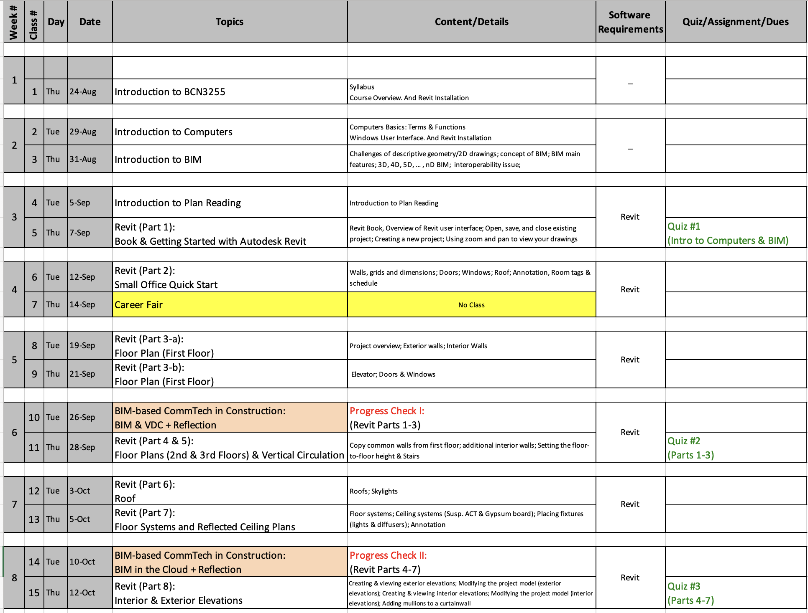
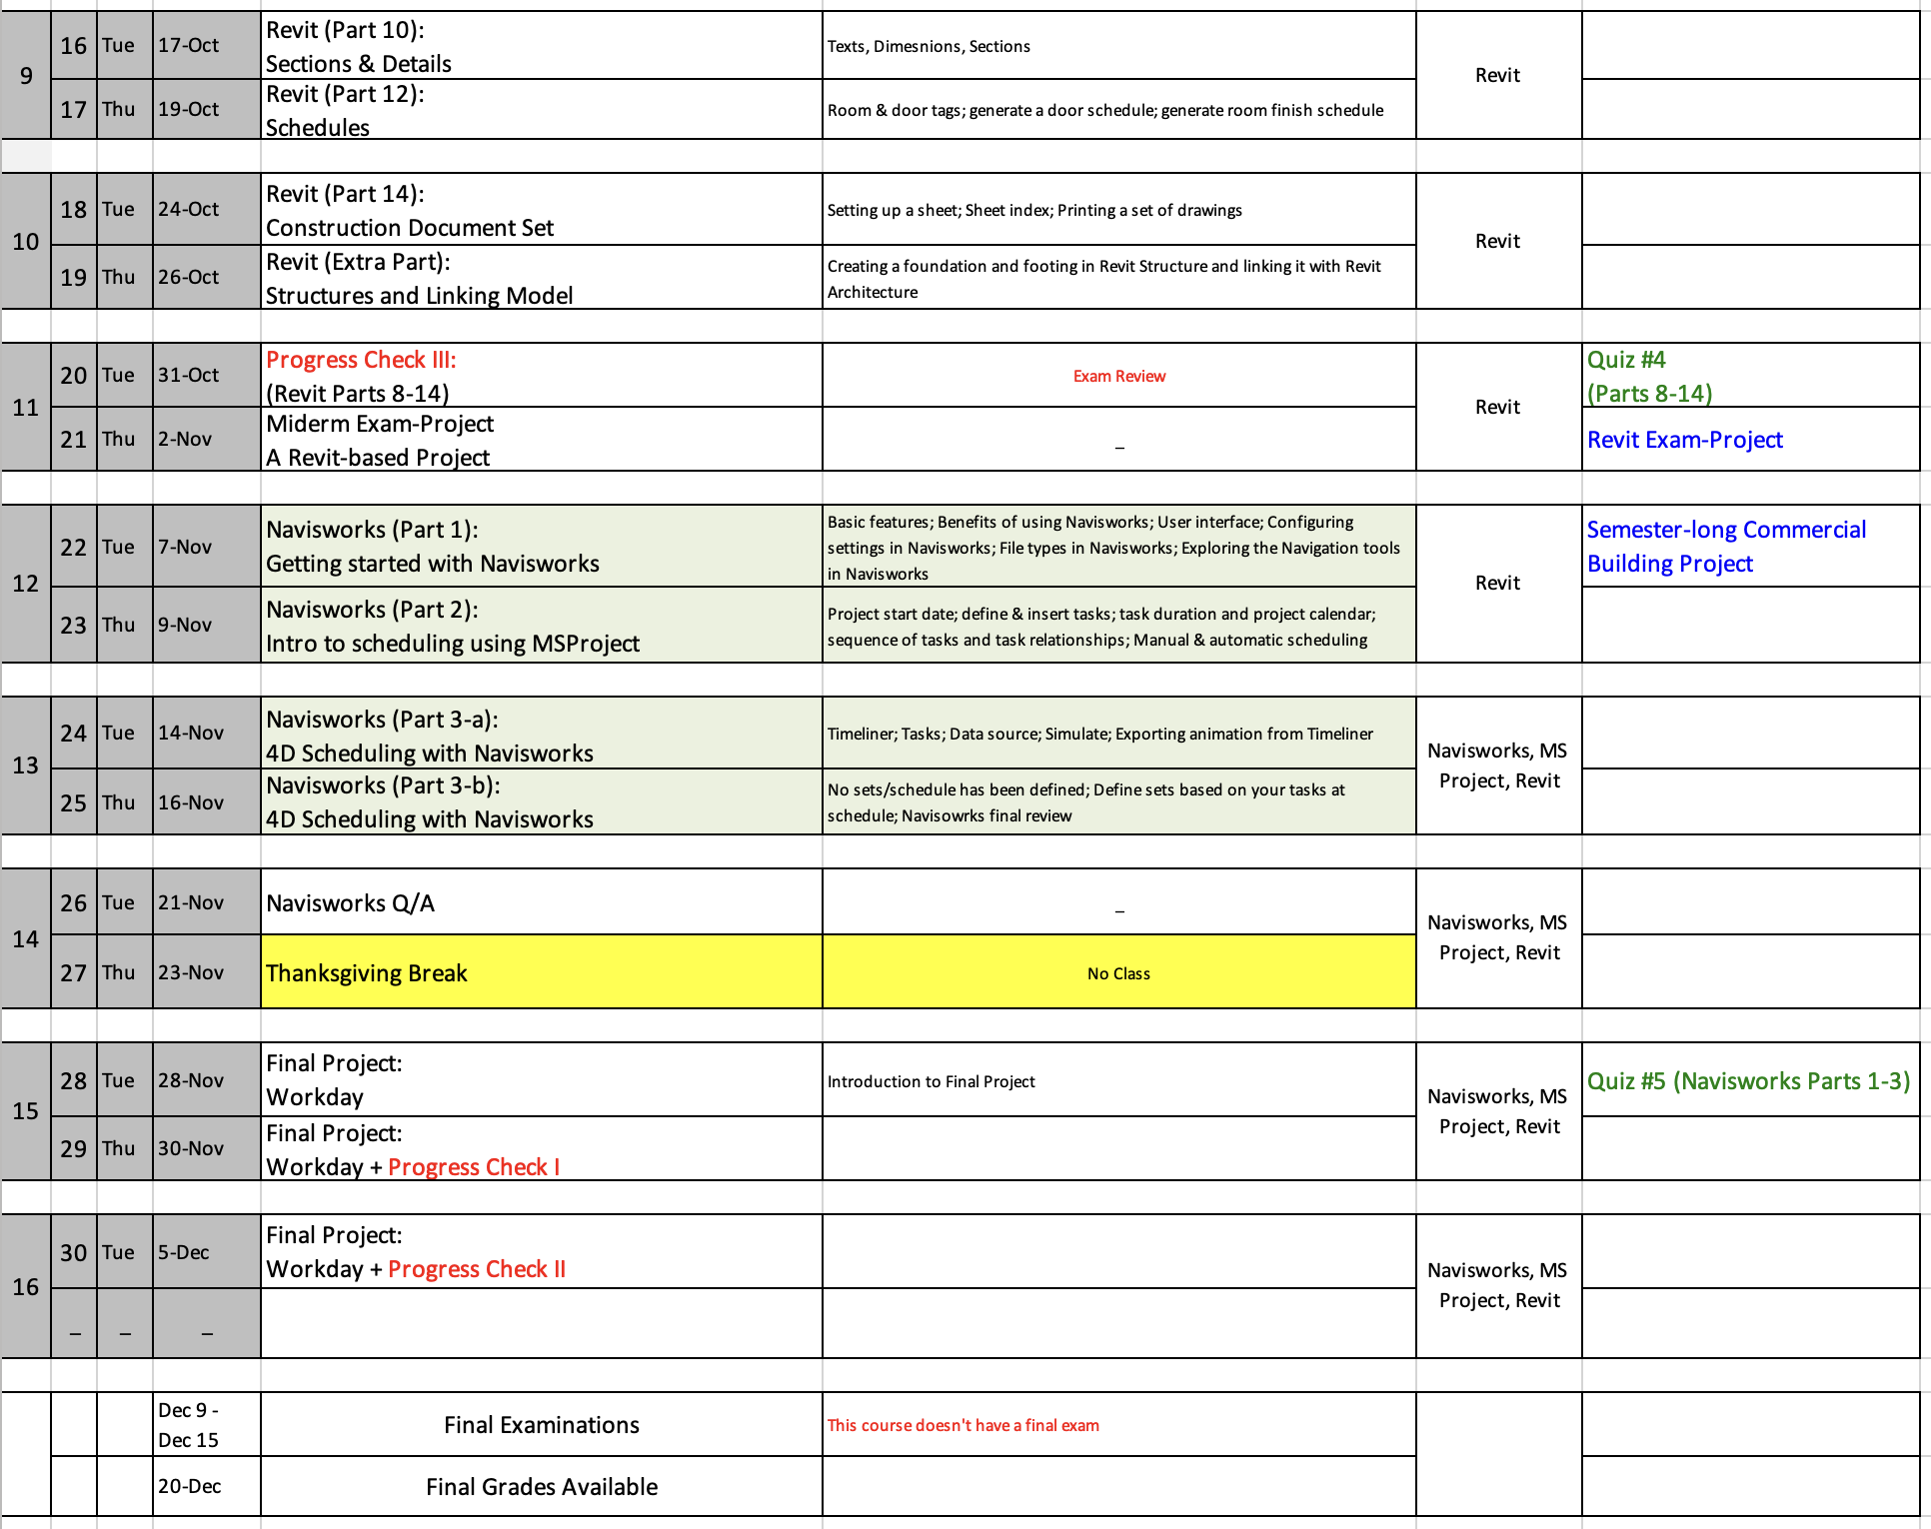
* The syllabus represents our current plans and objectives. As we move forward throughout the semester, those plans might need to be changed to enhance the class learning opportunity. Such changes, communicated clearly, are not unusual and should be expected.

COURSE ROADMAP

