2026 International Conference on Industrialized Construction:
Paper Formatting Instructions

Author1_FirstName Author1_LastName¹, and Author2_FirstName Author2_LastName²

¹ Title, School/Department, University, Country, author1@email_address.edu
² Title, School/Department, University, Country, author1@email_address.edu

Abstract
These instructions have been prepared in the format that should be used for the final manuscripts submitted to the 2026 International Conference on Industrialized Construction (IConIC), and are designed to help authors provide manuscripts that will comply with the defined paper format for the published proceedings. Papers should be a maximum of eight (8) letter-size pages in length, including text, figures, tables, references, and appendices. An up to 300-word abstract and 3-6 keywords are mandatory. The abstract should explain the purpose of your study in a clear manner, elucidate the content somewhat, and finish by stating the key findings from your study. Please avoid using special characters or objects in the abstract text, as this will create problems when reproducing the abstract. The main text should be logically subdivided into sections, which include abstract, keywords, introduction, methods, results and discussion, conclusions, and references. Format using 2.5 cm margins, 12 pt Times New Roman typeface, and single-line spacing. Include a running footer at the bottom of each page, 1.25 cm from the edge of the paper, with page numbers.

Keywords
Keyword1; Keyword2…

Introduction
This paper template may be used directly when typing the manuscript. Please also be sure to follow the guidelines in this paper template. These instructions have been prepared in the format that should be used for the final manuscripts and are designed to help you, the author, provide manuscripts that will translate well into a standard format. If final manuscript submissions do not comply with the template provided, they will not be included in the published conference proceedings.

The submission files must be in Microsoft Word file format (.doc or .docx).

Structure and content
All accepted papers will be distributed to the participants during the conference. Papers should be well structured, i.e., they must include:
- Full title: in the font of Times New Roman with size of 16 pt.
- Author name(s): Full Given Name(s) (First Letter in Capital) and followed by the SURNAME (ALL IN CAPITAL LETTERS), affiliation for each author, and corresponding author’s e-mail address.
- Abstract: no more than 300 words briefly specifying the aims of the work, the main results obtained, and the conclusions drawn.
- Keywords: 3–6 keywords.
- Main text: for clarity, this should be subdivided into:
  - Introduction - describing the background of the research presented and its aims, as well as a review of the relevant literature.
  - Methods - a brief description of the methods/techniques used (the principles of these methods should not be described if readers can be directed to easily accessible references or standard texts).
  - Results and Discussion - a clear presentation of the results obtained, highlighting any trends or points of interest.
- Conclusion: a brief explanation of the significance and implications of the work reported.
- Acknowledgements: a brief acknowledgement of funding bodies or individuals who have contributed but are not among the authors.
- References: references should be to accessible sources. Please ensure that all work cited in the text is included in the reference list, and that the dates and authors given in the in-text citations match those in the reference list (see below for formatting specifications).

The titles of the individual headings may vary depending on the nature of the paper, but it is important that a clear structure is preserved. Full papers should be a maximum of eight (8) pages in length, including text, figures, tables, and references.

Headings and layout
Major headings like the one above are typed bold in 14 pt uppercase (capital letters), with one line space above and none below.

Minor headings
Minor headings are in 12 pt bold type, not indented, with one line of space above and none below. Do not number the headings.

Sub-headings. Sub-headings are typed in 12 pt italics, not indented, with the paragraph running on after a full stop; there should be one line of space above.

Page layout
All text should be word-processed using the letter page size, respecting the following general layout requirements:

- Papers must be formatted using 2.5 cm margins.
- Please use a 12 pt Times New Roman typeface and single line spacing.
- Include a running footer with page numbers at the bottom of each page, 1.25 cm from the paper edge. Use Arabic numerals for page numbers.
- Normal paragraph text should be justified (extend to the right-hand margin) and be typed single line-spaced to fill the full depth of the text area.
- New paragraphs are not indented, but are preceded by a line of space. Also please avoid using footnotes or adding tables that span more than one page of the manuscript.
- For formatting of bulleted lists and numbered lists, refer to the examples shown in this paper template.

The first page
Special formatting requirements apply to the first page:

- The title of the paper should appear centred in 16 pt typeface as shown on the first page of this file. If you have a lengthy title, please consider a Title: Subtitle format. Allow one line space below the title. Leave one line space above the title.
- The author’s name(s) should appear centred in normal typeface, separated by commas and with one line space above and below. Indicate the corresponding author with an asterisk (*).
- The author’s affiliation(s) and simplified contact address(es) should be set out using centred 12 pt italicized typeface following the example on page 1 of this template.
- Show the corresponding author’s e-mail address in 10 pt italics below the affiliation(s).
- An abstract of up to 300 words should follow, with two line spaces above as with other major headings. 3-6 keywords should then follow, before the main text begins.

Table 1 contains the basic information related to page size and margin settings.

Figures and Tables
Figures and tables should be numbered consecutively as they are presented (Figure 1, Figure 2, etc., and Table 1, Table 2, etc.). A descriptive caption, including the figure or table number in boldface followed by a full stop, should be placed directly above tables and below figures. Every figure and table appearing in the paper should be referred to in the body of the text. Figures and tables should be positioned in close proximity to where they are first referred to in the text; we recommend (1) placement at the top or bottom of a page; and (2) not wrapping text around the figure/table, c.f., Figure 1 and Table 1. Allow two line spaces above/below tables/figures and make sure they fit within the margins of the text.

Table 1. This is an example of table layout. It shows the dimensions of the text area to be used for letter paper size. Table captions should be left-aligned, and should appear above the table.
 | Text area | A4 paper
 | (mm) | (mm) | (in)
Depth | 247 | 297 | 11.69
Top/bottom margin | - | 25 | 1.00
With | 160 | 210 | 8.27
Left/right margin | - | 25 | 1.00

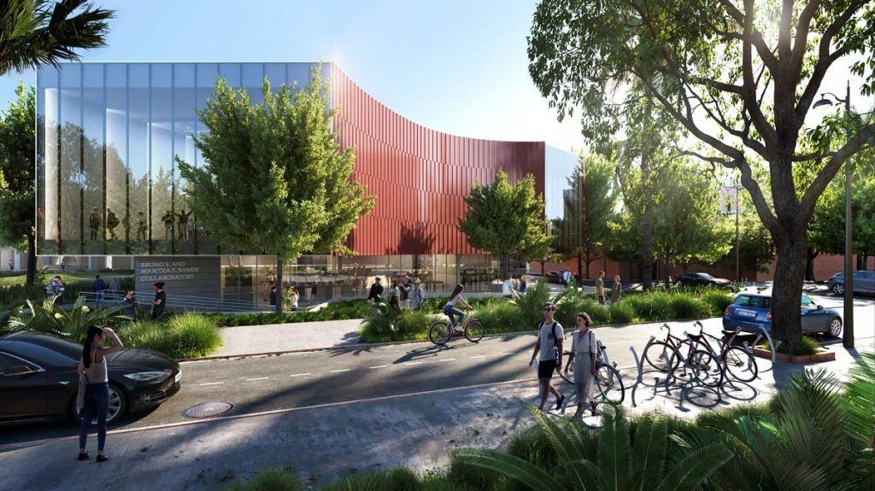
Figure 1. This is an example of a figure layout showing a view of the Bruno E. and Maritza F. Ramos Collaboratory at the University of Florida. Figure captions should be centred unless they exceed one line, in which case they should be left-aligned.

We recommend using a simple graphical layout to ensure that the colours do not cause problems when printing in black and white. Illustrations should be clear, and text in illustrations should be no smaller than 10 pt font size. Avoid using shading or greyscale as a background in your illustrations, as shading seldom reproduces well. Scanned images may appear muddy or unreadable on a computer screen; the quality of the printed image will vary depending on the output device of the user.

Figures should be of a sufficient resolution and appropriate colour scheme to allow printing of the paper in black and white on a normal laser printer. Please take care that excessively large graphics files are not included: 200 dpi JPEG graphics are usually satisfactory. Also, please do not insert spreadsheet graphics as embedded objects, as this will lead to very large files; instead copy and paste the picture via the clipboard as an enhanced metafile.

Mathematics, nomenclature, and units
All mathematics included in the text should be typed using an appropriate equation editor. Equations should be numbered sequentially.
$$RMS=\frac{\sqrt{\left(x_{1}+x_{2}+…+x_{i}\right)}}{n} i=1,2,…,n (1)$$
Please take care that all terminology and notation used will be widely understood. Abbreviations and acronyms should be spelled out in full at their first occurrence in the text.

SI units are strongly recommended. If non-SI units are necessary, SI equivalents (or conversion factors) must also be given. Units should have a single space between the number and the unit. Thousands should be separated by commas (e.g., 1,000). The decimal separator is a full stop (e.g., g = 9.81 m/s²).

Language
Papers should be in good, grammatically correct English (either American, Canadian, or British spelling are acceptable as long as one spelling is used consistently throughout). Have your paper read by at least two other persons to avoid typing errors.

Conclusion
It is a good idea to finish by clearly describing two or three “lessons learned” or findings that could include, for example, the main research findings or key findings of the work to pass along to practitioners for practical applications.

Acknowledgements
A brief acknowledgement of funding bodies or individuals who contributed but are not among the authors may follow the conclusion section. Do not express thanks to anonymous referees or editors.

References and citations
It is essential that papers include a list of references at the end, showing that the author is aware of and has cited earlier work in their field.

Both the in-text citations (https://apastyle.apa.org/style-grammar-guidelines/citations) and the list of references (https://apastyle.apa.org/style-grammar-guidelines/references) should be formatted according to APA style. References are listed alphabetically by last name of the first author. When two or more references by the same author are listed, year of publication is taken into account in determining the order in which they are listed, where the most recently published work is listed first. The following is an example of a parenthetical in-text citation: (Moayyed et al., 2025). In your paper, do not list sources in the reference list that are not cited in the text.

We thank you for your efforts reading through these paper guidelines, and we look forward to receiving your manuscript.

REFERENCES (examples of each type of source are included below for your reference)

Moayyed, E., Anumba, C., & Morteza, A. (2025). Systematic analysis of large language models for automating document-to-smart contract transformation. Automation in Construction, 175, 106209.
Tehrani, B. M., & Alwisy, A. (2025). Optimizing Task Allocation in Human-in-the-Lead Construction Robotics: A Framework for Wood Assembly–Based Robotics in Panelized Construction. Journal of Computing in Civil Engineering, 39(6), 04025097.
Xu, F., Bao, H., Zhou, T., You, H., Gabbard, J., Du, J., & Ledgerwood, S. (2025). Augmented Reality Visualization for Enhanced Spatial-Temporal Cognition in Indoor Emergency Response.

