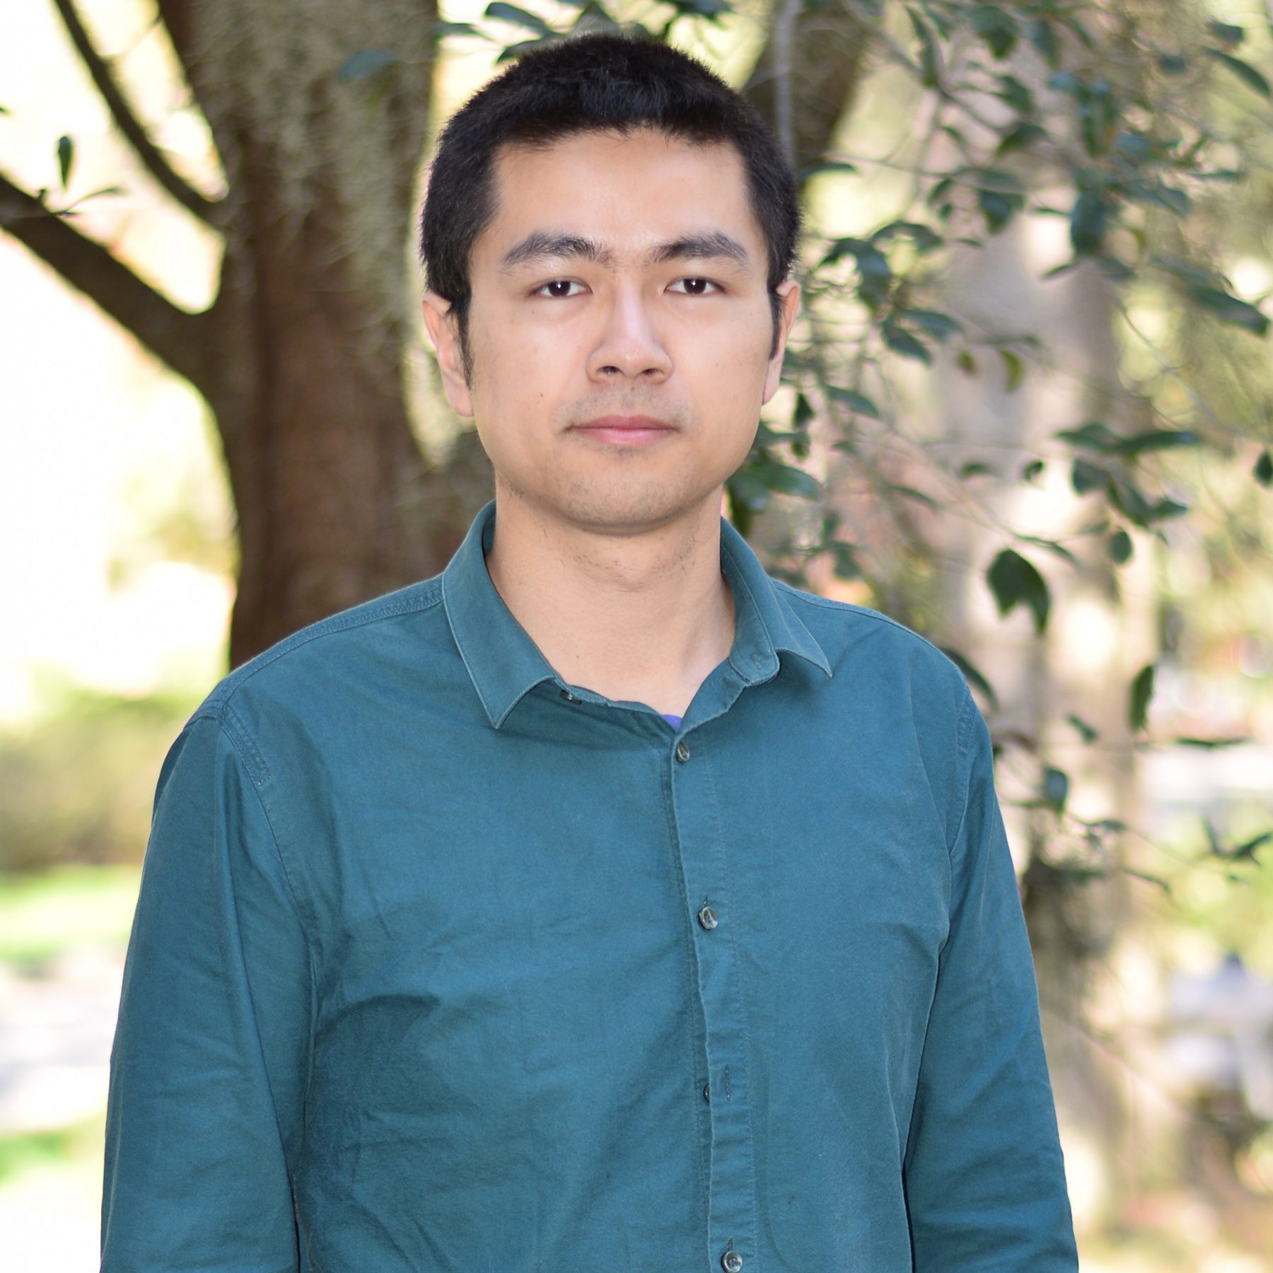Name: Wei Zhai

Phone: (352)3286624

Email: [wei.zhai@ufl.edu](mailto:wei.zhai@ufl.edu)

[Google Scholar](https://scholar.google.com/citations?user=Vz8kG8IAAAAJ&hl=en)

Research Interests: Post-Disaster Recovery Planning; Transportation Planning; Spatial Data Science

**EDUCATION**

**2017-2021(expected):** Ph. D. Degree in Urban and Regional Planning, University of Florida, FL, USA.

Advisor: Prof. Zhong-ren Peng

**2019-2021(expected):** Master’s Degree in Electrical and Computer Engineering, University of Florida, FL, USA.

GPA:3.9

**2015-2017:** Master’s Degree in Urban Planning, Tsinghua University, Beijing, China. (Honor in thesis)

Advisor: Prof. Chaolin Gu

**2010-2015:** Bachelor’s Degree in Urban Planning, Hunan University, Changsha, China. (Honor)

**JOURNAL PAPERS**

* **Zhai, W**., Bai, X., Shi, Y., Han, Y., Peng, Z. R., & Gu, C. (2019). Beyond Word2vec: An approach for urban functional region extraction and identification by combining Place2vec and POIs. *Computers, Environment and Urban Systems*, 74, 1-12.
* **Zhai, W.,** Bai, X., Peng, Z. R., & Gu, C. (2019). From edit distance to augmented space-time-weighted edit distance: Detecting and clustering patterns of human activities in Puget Sound region. *Journal of Transport Geography*, 78, 41-55.
* **Zhai, W.,** Bai, X., Peng, Z. R., & Gu, C. (2019). A bottom-up transportation network efficiency measuring approach: A case study of taxi efficiency in New York City. *Journal of Transport* Geography, 80. 102502.

**BOOK REVIEW**

* **Zhai, W**. (2018). How to Kill a City: Gentrification, Inequality, and the Fight for the Neighborhood, by Peter Moskowitz. Journal of the American Planning Association, 84(2), 203-203.

**BOOK**

* Gu, C, Gerhard, O, Feng G, **Zhai, W**. Introduction to Human Geography. Beijing: Science Press. 2016 (in Chinese)

**TEACHING**

* Teaching Assistant, Tsinghua University, Summer 2016, Introduction to Human Geography.
* Teaching Assistant, University of Florida, Spring 2019, URP 6821 Transportation and Land Use Model (4.75/5.0)
* Citespace Tutorial, University of Florida, Fall 2019, DCP 7794 Doctoral Seminar

**ACADEMIC AWARDS&SCHOLARSHIP**

* **Excellent Prize** in Urban Design Competition (Awarded by National Steering Committee of Urban and Rural Planning Education), Shen Zhen, China, 2014.
* **Excellent Prize** in Urban Transportation Competition (Awarded by National Steering Committee of Urban and Rural Planning Education), Shen Zhen, China, 2014.
* **First Prize** (top 1.5%) in 11th Excellent Design Exhibition of Hunan Province, 2014.
* **TianAn-ShuiShi Enterprise Scholarship**, 2015.
* **National Scholarship** (top 3%) (Awarded by The Ministry of Education of China), 2014.
* **First Prize Scholarship of Hunan University** (top 10%), 2012.
* **National Scholarship** (top 3%) (Awarded by The Ministry of Education of China), 2011.

**PRESENTATIONS&TALK**

* **UF DCP Doctoral Program Orientation, September 2019**. Publishing as a junior doctoral student. Gainesville, FL.
* **ACSP, October 2018**. Measure the local and global commuting efficiency: An exploratory analysis of taxi commuting in New York City. Buffalo, NY.
* **AAG, April 2018.** An approach for urban functional region identification and extraction: Combining Word2vec model and multisource data. New Orleans, LA.

**PROJECT EXPIERENCE**

**Research Project,** University of Florida (2019.09-2020.05)

* Evaluating the effectiveness and funding mechanism of the Downtowner service in Tampa, Florida for statewide application (funded by FDOT). Major Participant**.**
* Evaluating the connection between transit and TNCs (Transportation Network Companies) in Pinellas County for statewide application (funded by FDOT). Major Participant**.**

**Research Project,** Tsinghua University (2015.09-2017.05)

* Interactive Coupling System Model of Urbanization and Ecological Environment in Mega-Cities. (funded by National Natural Science Foundation of China). Major Participant.
* Strategic Research on Global Urbanization and China’s Urban System Development. (funded by Ministry of Housing and Urban-Rural Development of China). Major Participant**.**

**Planning Practice Project,** China Academy of Urban Planning and Design Intern (2014.09-2014.12, 2016.09-2016.12)

* Comprehensive Plan of Wuxi City, Jiangsu Province, 2016.
* Comprehensive Plan of Liupanshui City, Guizhou Province, 2014.
* The Urban-rural Integration Development Planning of Hainan Province, 2014.

**Planning Practice Project,** Architectural Design and Research Institute of Hunan University Intern (2013.06-2013.09)

* Dazehu Conceptual Planning and Design, 2013.
* The Development Conceptual Plan of Hongjiang Ancient Districts, 2013.

**TECHNICAL SKILL**

* Programing Language: Python, R, MATLAB
* Software: Auto CAD 2010, Sketch Up, Photoshop CS4, Arcgis 10.0, Cube, TransCAD